

**19F CST8276_010 Advanced Database Topics**

**Vi Thi Phuong Pham**

**Exercise 01**

# Program source code

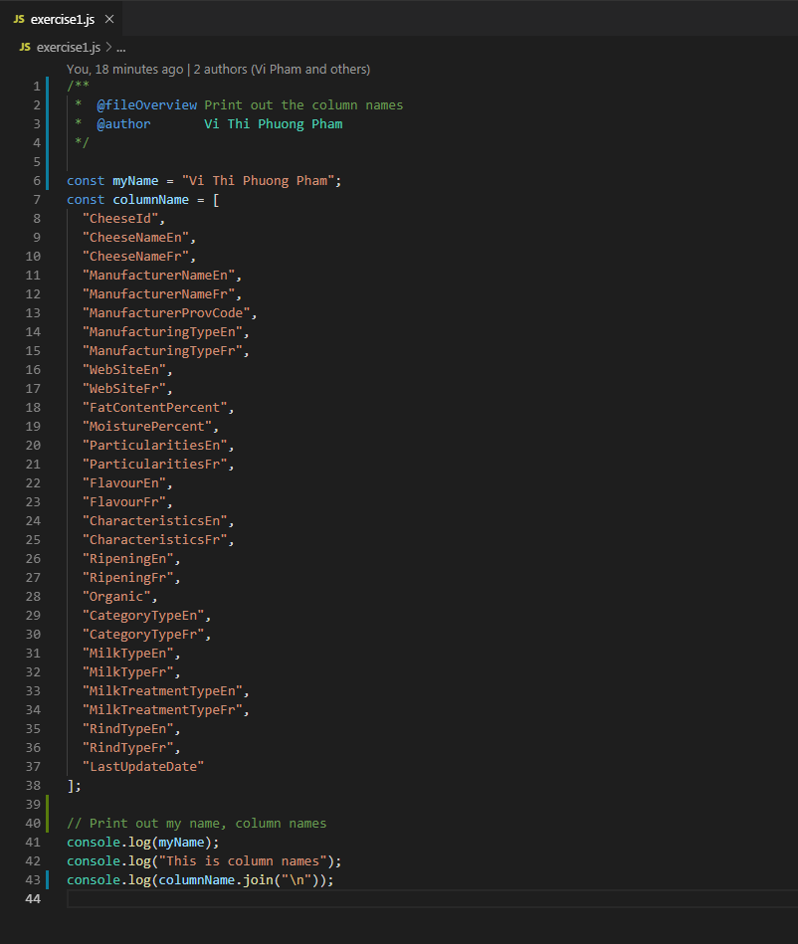

# Learning resources

|  |  |
| --- | --- |
| [1] | "Google JavaScript Style Guide," Google Company, [Online]. Available: https://google.github.io/styleguide/jsguide.html#formatting-comments. [Accessed 06 09 2019]. |
| [2] | S. Ganeshram, "JSDoc-Style-Guide," Github, [Online]. Available: https://github.com/shri/JSDoc-Style-Guide#variables-and-constants. [Accessed 06 09 2019]. |

# Screen shot of program execution

